**NOAA Ship THOMAS JEFFERSON Procedure Document**

Procedure:

**Static draft**

Creation Date:

08/27/2020

Revision Date:

Software used:

Excel

Procedure Number:

**TBD**

Approved:

**TBD**

# Overview and Scope

How to take a static draft for S222 and the launches.

# Procedure Inputs and Outputs

## Inputs:

## Outputs:

# Procedure

Launches

To take a static draft on the launches you need to measure from the benchmarks on the port and starboard side to the water. Using a plumb and a level is the easiest method. You only need the vertical measurement as X and Y to the benchmark do not matter for waterline. Measurements need to be taken with a near empty fuel tank and at a full tank. Note the fuel levels. Use the spread sheet found at the link below. Measurements must be in meters and you should only need to put the values within the green cells and then note the tank levels (See image below). Formulas will calculate the waterline measurement. The cell with the Overall WL Average is the value you should use for the HVF and within SIS.

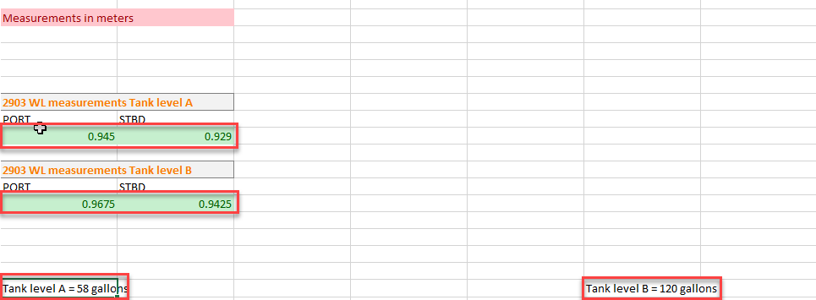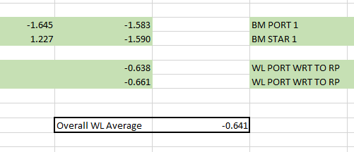

**S222**

Waterline measurements are taken with the sutron bubbler on the ship. Follow the startup SOP

Once the system is up and running you need to take at least 10 measurements. These measurements are averaged logged within the acquisition log or an excel sheet. The average value is put into the HVF and SIS.

# References